Sequence: Conceptual Level

Use familiar pictures to build / connect to the concept of the text structure.

Sequence

1.

2.

3.

4.

5.

6.

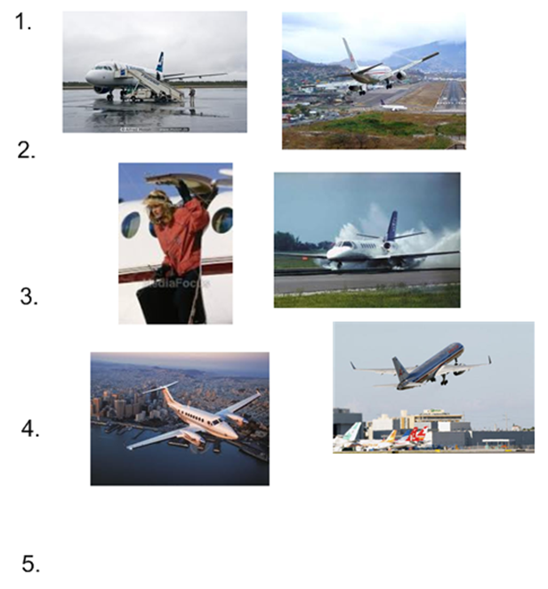





**Other examples:**

* **Recipe**
* **Daily school schedule**
* **Daily routines**

[**lmayer@revere.mec.edu**](mailto:lmayer@revere.mec.edu)

Sequence

1.

2.

3.

4.

5.

6.

Connect the pictures to the signal words of the given text structure.

* First, To begin, At the beginning
* Next, Then, After
* Last, Finally, In the end

Sequence: Word Level

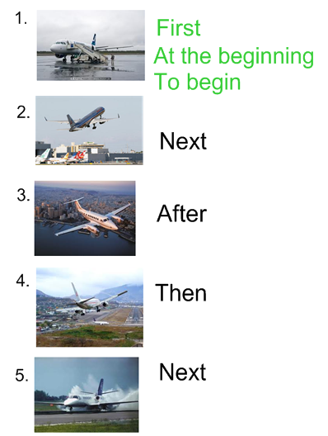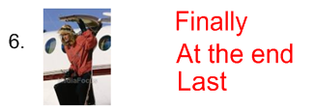

Sequence

1.

2.

3.

4.

Embed the concept and signal words into the thematic unit students are studying. Students use their knowledge of the content and signal words to describe pictures.

Sequence: Sentence Level

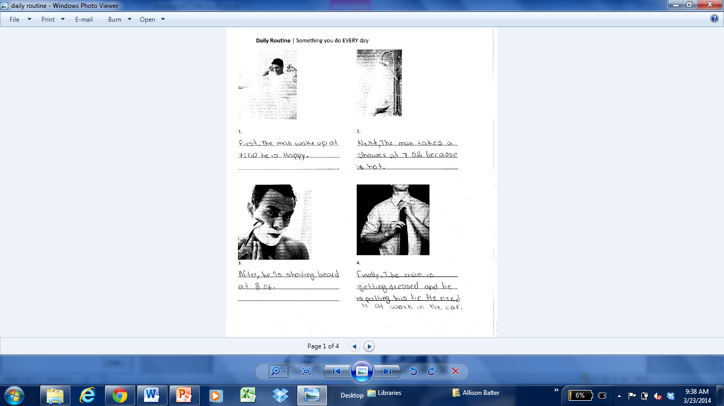

[**lmayer@revere.mec.edu**](mailto:lmayer@revere.mec.edu)

Sequence: Discourse Level

Students connect their previously written sentences to form an organized and structured paragraph. Modeling and co-constructing paragraphs first enables students to do this on their own.

